Train the Model on IBM

|  |  |
| --- | --- |
| Date | 31 October 2022 |
| Team ID | PNT2022TMID53813 |
| Project Name | Car Resale Value Prediction |

# Register for IBM Cloud

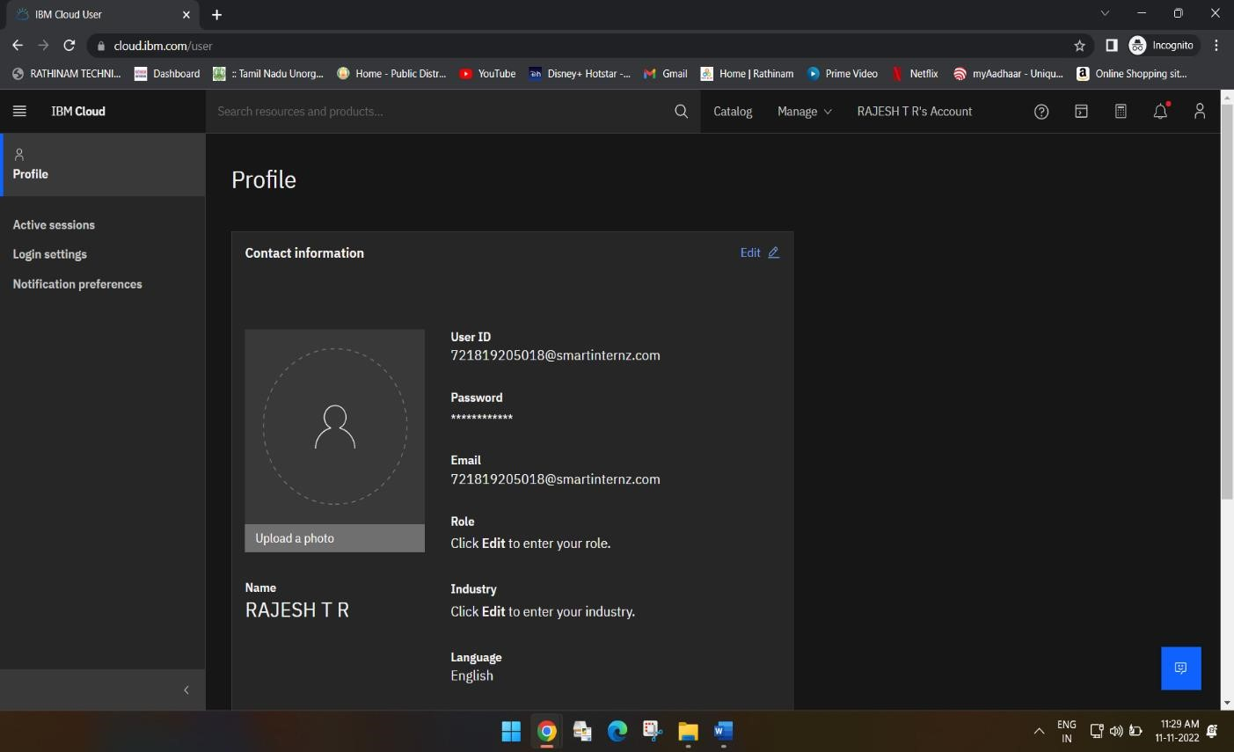

# Train the ML model on IBM

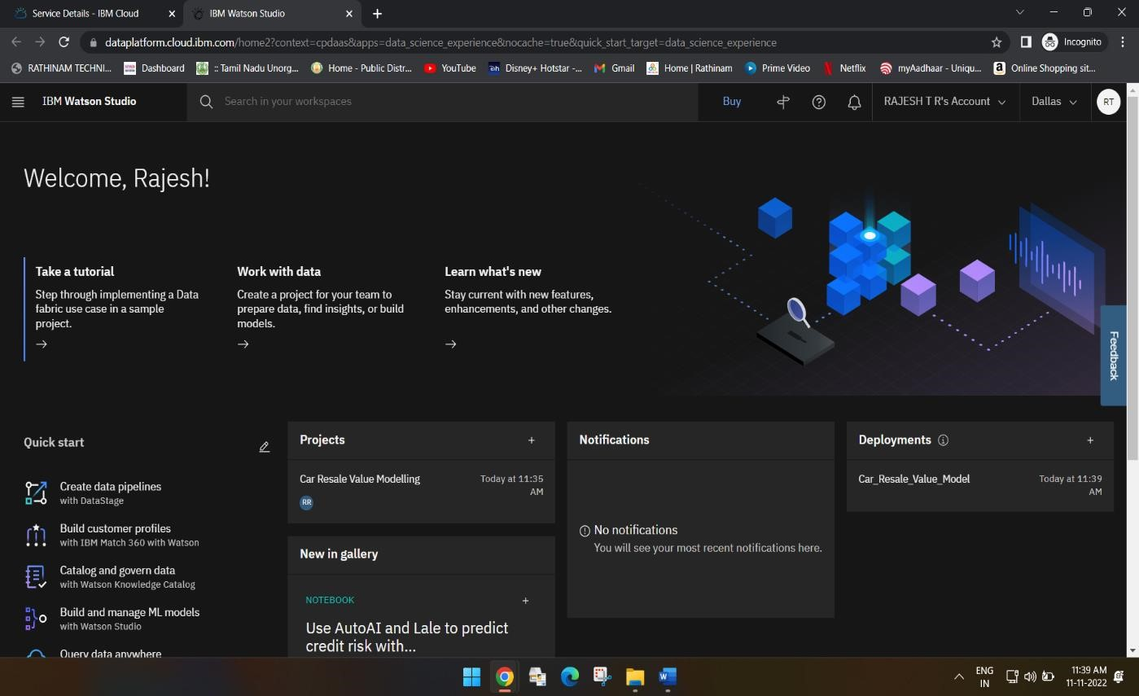

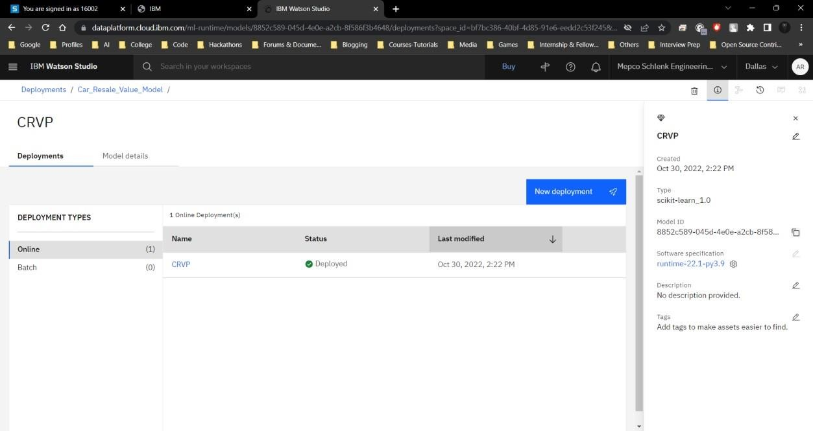

# Integrate Flask with Scoring End Point

